Lab Exercise 5: TCP Congestion Control and Fairness

zid: z5228006 name: MINGLANG XIE

# Exercise 1: Understanding TCP Congestion Control using ns-2

We have studied the TCP congestion control algorithm in detail in the lecture (and Section 3.6 of the text). You may wish to review this before continuing with this exercise. Recall that, each TCP sender limits the rate at which it sends traffic as a function of perceived network congestion. We studied three variants of the congestion control algorithm: TCP Tahoe, TCP Reno and TCP new Reno.

We will first consider TCP Tahoe (this is the default version of TCP in ns-2). Recall that TCP Tahoe uses two mechanisms:

* A varying congestion window, which determines how many packets can be sent before the acknowledgment for the first packet arrives.
* A slow-start mechanism, which allows the congestion window to increase exponentially in the initial phase, before it stabilises when it reaches threshold value. A TCP sender re-enters the slow-start state whenever it detects congestion in the network.

The provided script, [tpWindow.tcl](https://webcms3.cse.unsw.edu.au/COMP3331/20T3/resources/52066)implements a simple network that is illustrated in the figure below.

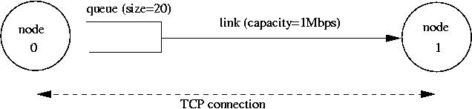

Node 0 and Node 1 are connected via a link of capacity 1 Mbps. Data traffic will only flow in the forward direction, i.e. from Node 0 to Node 1. Observe that packets from node 0 are enqueued in a buffer that can hold 20 packets. All packets are of equal size and are equal to the MSS.

The provided script accepts two command line arguments:

* the maximum value of the congestion window at start-up in number of packets (of size MSS).
* The one-way propagation delay of the link

You can run the script as follows:

$ns tpWindow.tcl <max_cwnd> <link_delay>

**NOTE:**The NAM visualiser is disabled in the script. If you want to display the NAM window (graphical interface), then uncomment the fifth line of the 'finish' procedure (i.e. remove the "#"):

proc finish {} {

global ns file1 file2

$ns flush-trace

close $file1

close $file2

#exec nam out.nam &

exit 0

}

We strongly recommend that you read through the script file to understand the simulation setting. The simulation is run for 60 seconds. The MSS for TCP segments is 500 bytes. Node 0 is configured as a FTP sender which transmits a packet every 0.01 second. Node 1 is a receiver (TCP sink). It does not transmit data and only acknowledges the TCP segments received from Node 0.

The script will run the simulation and generate two trace files: (i) *Window.tr,*which keeps track of the size of the congestion window and (ii) *WindowMon.tr*, which shows several parameters of the TCP flow.

The *Window.tr*file has two columns:

time congestion_window_size

A new entry is created in this file every 0.02 seconds of simulation time and records the size of the congestion window at that time.

The *WindowMon.tr*file has six columns:

time number_of_packets_dropped drop_rate throughput queue_size avg_tput

A new entry is created in this file every second of simulation time. The *number_of_packets_dropped*, *drop_rate*and *throughput*represents the corresponding measured values over each second. The *queue_size*indicates the size of the queue at each second, whereas *avg_tput*is the average throughput measured since the start of the simulation.

***Question 1: Run the script with the max initial window size set to 150 packets and the delay set to 100ms (be sure to type "ms" after 100). In other words, type the following:***

***$ns tpWindow.tcl 150 100ms***

***In order to plot the size of the TCP window and the number of queued packets, we use the provided gnuplot script***[***Window.plot***](https://webcms3.cse.unsw.edu.au/COMP3331/20T3/resources/52076)***as follows:***

***$gnuplot Window.plot***

***What is the maximum size of the congestion window that the TCP flow reaches in this case? What does the TCP flow do when the congestion window reaches this value? Why? What happens next? Include the graph in your submission report.***

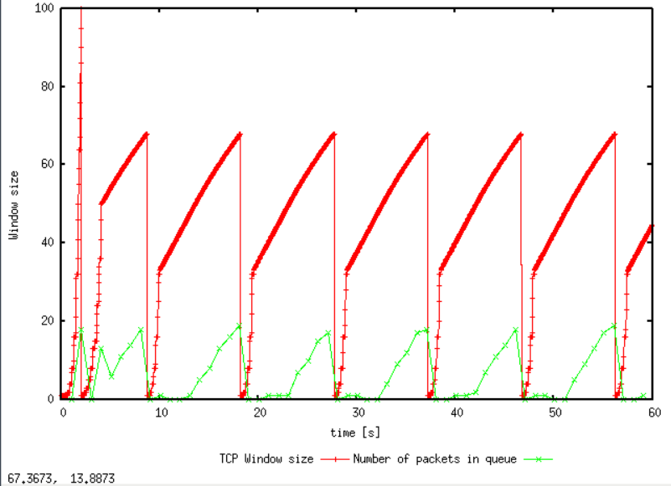

The maximum size of the congestion window is 100 packets, although we have set the maximum congestion window to 150 packets. When the congestion window reaches 100 packets, packets get dropped which results in a congestion event (either triple duplicate acks or timeout, TCP Tahoe does not distinguish between these two) at the sender. The sender thus reduces the congestion window to 1 and threshold to 1/2 the size of the window, which is 50 packets. Then the connection enters slow start and grow exponentially until hit the threshold. Following this the connection transitions to congestion avoidance phase.

***Question 2: From the simulation script we used, we know that the payload of the packet is 500 Bytes. Keep in mind that the size of the IP and TCP headers is 20 Bytes, each. Neglect any other headers. What is the average throughput of TCP in this case? (both in number of packets per second and bps)***

***You can plot the throughput using the provided gnuplot script***[***WindowTPut.plot***](https://webcms3.cse.unsw.edu.au/COMP3331/20T3/resources/52084)***as follows:***

***$gnuplot WindowTPut.plot***

***This will create a graph that plots the instantaneous and average throughput in packets/sec. Include the graph in your submission report.***

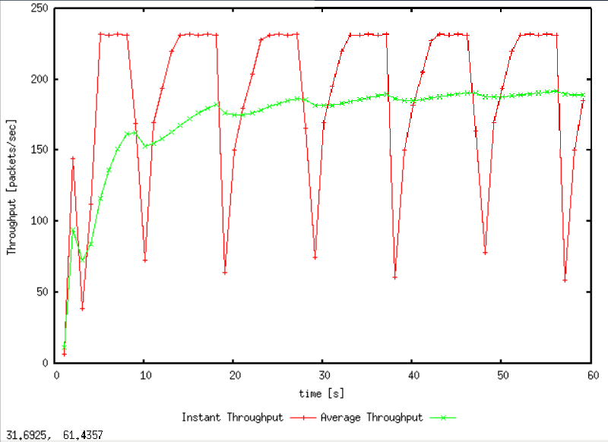

According to the graph, the average throughput of TCP in packets per second is 190 pps.

There are two kind of bps, one is including header and payload data, the other only includes the payload

For throughput including header and payload data:

$$190*\left(500+20+20\right)*8=820.8 Kbps$$

For throughput only including payload data:

$$190*500*8=760 Kbps$$

***Question 3: Rerun the above script, each time with different values for the max congestion window size but the same RTT (i.e. 100ms). How does TCP respond to the variation of this parameter? Find the value of the maximum congestion window at which TCP stops oscillating (i.e., does not move up and down again) to reach a stable behaviour. What is the average throughput (in packets and bps) at this point? How does the actual average throughput compare to the link capacity (1Mbps)?***

The initial max congestion window is set to 66

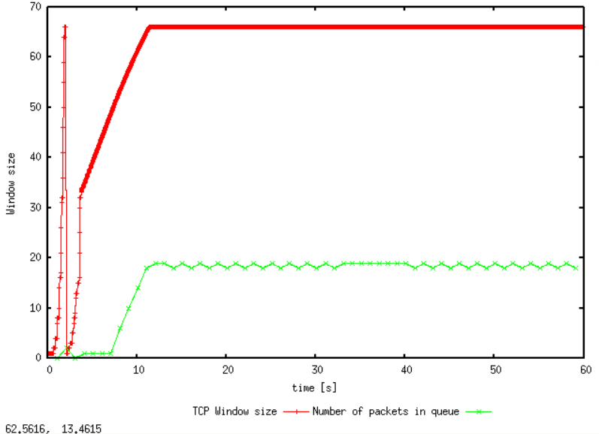

The initial max congestion window is set to 50

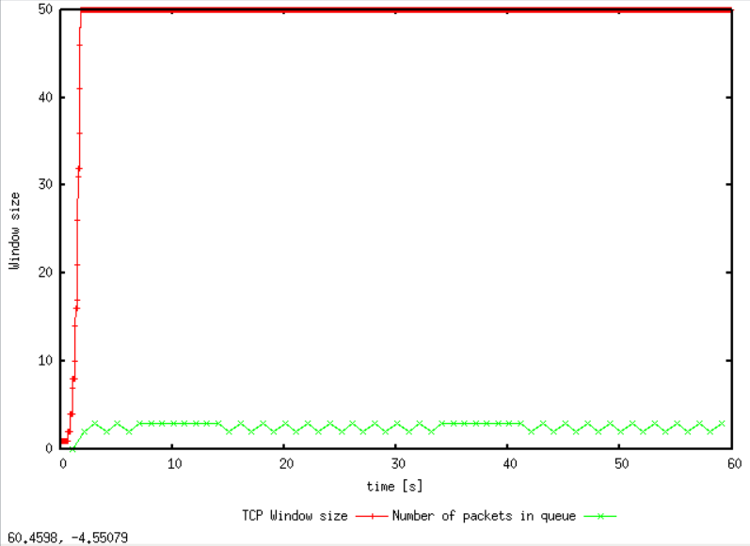

Average throughput when the initial max congestion window is set to 50

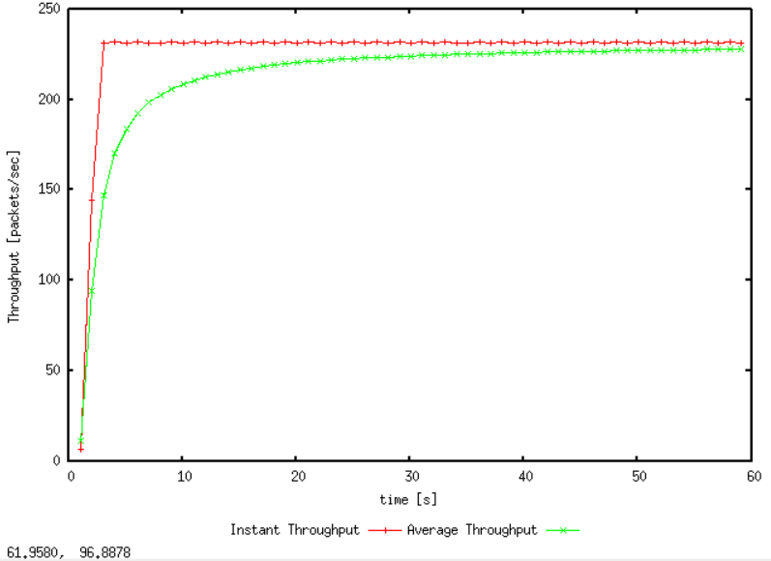

When the initial maximum congestion window is set to 50, TCP stabilizes immediately. The average packet throughput is 225 pps. The average throughput is

$$225*500*8=900 Kbps$$

Which is almost equal to the link capacity (1 Mbps)

***TCP Tahoe vs TCP Reno***

***Recall that, so far we have observed the behaviour of TCP Tahoe. Let us now observe the difference with TCP Reno. As you may recall, in TCP Reno, the sender will cut the window size to 1/2 its current size if it receives three duplicate ACKs. The default version of TCP in ns-2 is TCP Tahoe. To change to TCP Reno, modify the Window.tcl OTcl script. Look for the following line:***

***set tcp0 [new Agent/TCP]***

***and replace it with:***

***set tcp0 [new Agent/TCP/Reno]***

***Question 4: Repeat the steps outlined in Question 1 and 2 (NOT Question 3) but for TCP Reno. Compare the graphs for the two implementations and explain the differences. (Hint: compare the number of times the congestion window goes back to zero in each case). How does the average throughput differ in both implementations?***

***Note: Remember to include all graphs in your report.***

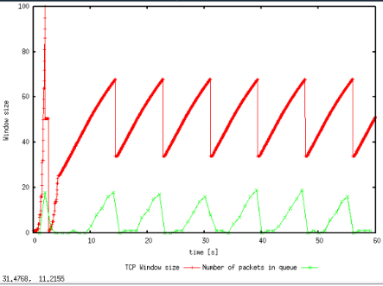**Q1:**

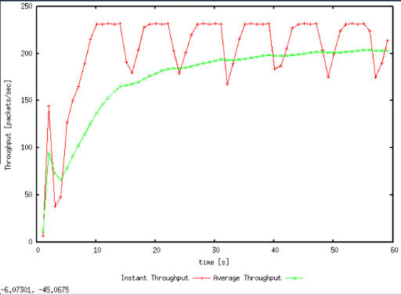TCP Reno does not enter slow start in most of the part (except one timeout event at the start). Whenever a congestion event occurs, the sender halves its current congestion window and increases it linearly, until losses starts taking place again. It is different to TCP Tahoe where reduced the window to 1 after each congestion event.

The throughput is 200 pps which is higher than TCP Tahoe. Because TCP Reno does not need to initiate slow start after each congestion event.

### Exercise 2: Flow Fairness with TCP

In this exercise, we will study how competing TCP flows with similar characteristics behave when they share a single bottleneck link.

The provided script, [tp_fairness.tcl](https://webcms3.cse.unsw.edu.au/COMP3331/20T3/resources/52075)generates 5 source-destination pairs which all share a common network link. Each source uses a single TCP flow which transfers FTP traffic to the respective destination. The flows are created one after the other at 5-second intervals (i.e., flow *i+1*starts 5 seconds after flow *i*for *i*in *[1,4]*). You can invoke the script as follows

$ns tp_fairness.tcl

The figure below shows the resulting topology; there are 5 sources (2,4,6,8,10), 5 destinations (3,5,7,9,11), and each source is sending a large file to a single destination. Node 2 is sending a file to Node 3, Node 4 is sending a file to Node 5, and so on.

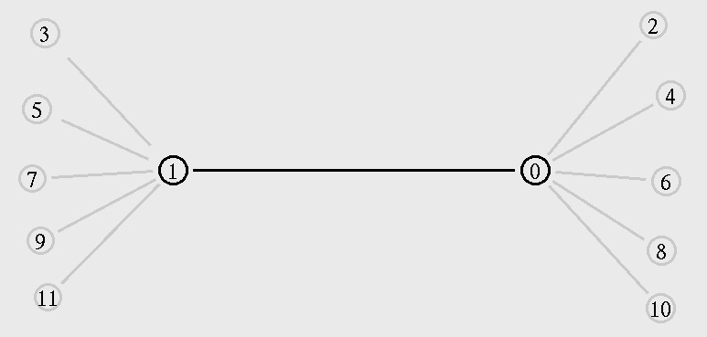

The script produces one output file per flow; farinessMon i .tr for each *i*in *[1,5]*. Each of these files contains three columns:

time | number of packets delivered so far | throughput (packets per second)

You can plot the throughput as a function of time using the provided gnuplot script, [fairness_pkt.plot](https://webcms3.cse.unsw.edu.au/COMP3331/20T3/resources/52058), as follows:

$gnuplot fairness_pkt.plot

**NOTE:**The NAM visualiser is disabled in the script. If you want to display the NAM window (graphical interface), modify tp_fairness.tcl and uncomment the fifth line of the 'finish' procedure:

proc finish {} {

global ns file1 file2

$ns flush-trace

close $file1

close $file2

#exec nam out.nam &

exit 0

}

Run the above script and plot the throughput as a function of time graph and answer the following questions:

***Question 1: Does each flow get an equal share of the capacity of the common link (i.e., is TCP fair) ? Explain which observations lead you to this conclusion.***

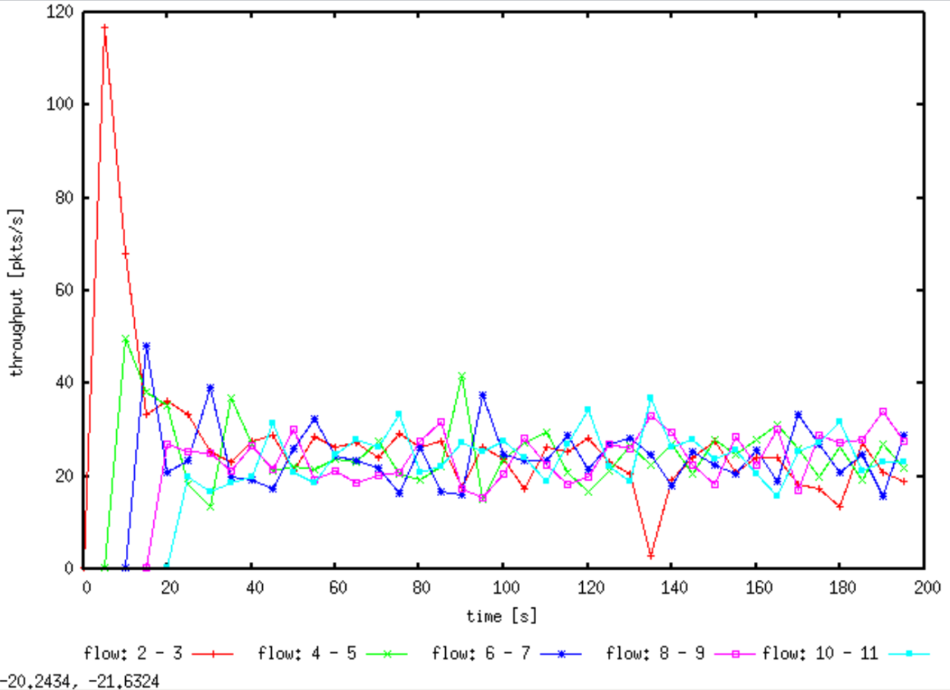

Each flow does get an equal share of the capacity of the common link, after 20 seconds, the throughput for all 5 connections is similar. This is because the AIMD congestion control will make the window adapted for long-term fairness when multiple flows share a bottleneck link.

Question 2. What happens to the throughput of the pre-existing TCP flows when a new flow is created? Explain the mechanisms of TCP which contribute to this behaviour. Argue about whether you consider this behaviour to be fair or unfair.

When a new flow is created, its congestion window is ramps up during slow start and creates congestion on the link. Thus, the pre-existing TCP flows is reduced. A congestion event occurs in all existing TCP flows, and adapt the size of their congestion window to abode overwhelming the network, This is fair, since a new flow is added, the fair share of all existing flows should be reduce.

### Exercise 3: TCP competing with UDP

In this exercise, we will observe how a TCP flow reacts when it has to share a bottleneck link that is also used by a UDP flow.

The provided script, [tp_TCPUDP.tcl](https://webcms3.cse.unsw.edu.au/COMP3331/20T3/resources/52069), takes a link capacity value as a command line argument. It creates a link with the given capacity and creates two flows which traverse that link, one UDP flow and one TCP flow. A traffic generator creates new data for each of these flows at a rate of 4Mbps. You can execute the simulation as follows,

$ns tp_TCPUDP <link_capacity>

After the simulation completes, you can plot the throughput using the provided gnuplot script, [TCPUDP_pps.plot](https://webcms3.cse.unsw.edu.au/COMP3331/20T3/resources/52063), as follows,

$gnuplot TCPUDP_pps.plot

***Question 1: How do you expect the TCP flow and the UDP flow to behave if the capacity of the link is 5 Mbps ?***

***Now, you can use the simulation to test your hypothesis. Run the above script as follows,***

***$ns tp_TCPUDP.tcl 5Mb***

***The script will open the NAM window. Play the simulation. You can speed up the simulation by increasing the step size in the right corner. You will observe packets with two different colours depicting the UDP and TCP flow. Can you guess which colour represents the UDP flow and the TCP flow respectively ?***

Expect If the capacity of the link is 5 Mbps, both TCP and UPD’s throughput will increased. However, UDP has no congestion control whereas TCP has a built-in congestion control. Thus, UDP have a higher throughput than TCP.

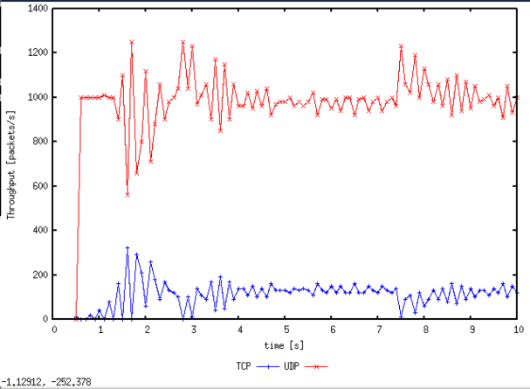

Question 2: Why does one flow achieve higher throughput than the other? Try to explain what mechanisms force the two flows to stabilise to the observed throughput.

As expected, UPD have higher throughput than TCP, because UPD does not have congestion control. UPD transmits packet at a constant rate though the packet gets lost or dropped. Nevertheless, TCP reduces its transmission rate when after each congestion event.

***Question 3: List the advantages and the disadvantages of using UDP instead of TCP for a file transfer, when our connection has to compete with other flows for the same link. What would happen if everybody started using UDP instead of TCP for that same reason?***

If using UPD instead of TCP for a file transfer, the advantages would be that the sender could keep transmitting unrestrained at a constant rate. Thus, UPD has a higher throughput than TCP. The disadvantage would be that the file transfer is unreliable, which means the data is not guarantee that be receive by the receiver. Also, a link might end up collapsing and blocking.

If everybody started using UPD instead of TCP, the network will be congested since everyone transmitting packet at unrestrained rate. Lots of packets will get lost since the network is overwhelm, and the network would most likely block.